Riphah International University
I-14 Campus Islamabad
Lab_Task_03
Department: Data Science
Subject: Data Structure
Submitted By:
Hammad Sajjad Awan
SAP ID:
76142
Submitted To:
Junaid Khan
Date Of Submission:
16-09-2026

Lab Report
Lab Activity 1:
Task_01:
Activity 1 — Foundational & Structural Recursion
i- Mathematical Recursion (Factorial)
Create a Java program that calculates the factorial of a user-specified integer using recursion.
The program should:
- Identify the Base Case where
- Implement the Recursive Step
Solution:
Base Case:
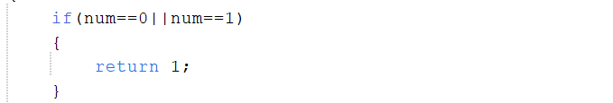
Recursive Step:

Complete Code:
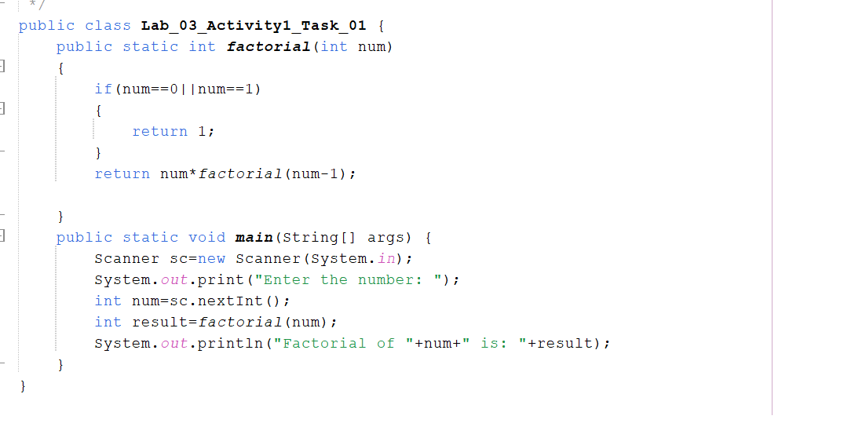
Output:
Task_02:
ii- Structural Array Traversal Recursion
Create a Java program that processes elements of a one-dimensional array without using any for, while, or do-while loops.
Use the following input array:
Array {12, 45, 7, 23, 56, 89, 34}
- Recursive Traversal: Print all elements from index 0 to length - 1.
- Recursive Statistics: Compute and return the total Sum of all elements.
- Recursive Search: Search for a target value. Return its index position if found, or -1 if absent.
Solution:

Recursive Traversal:
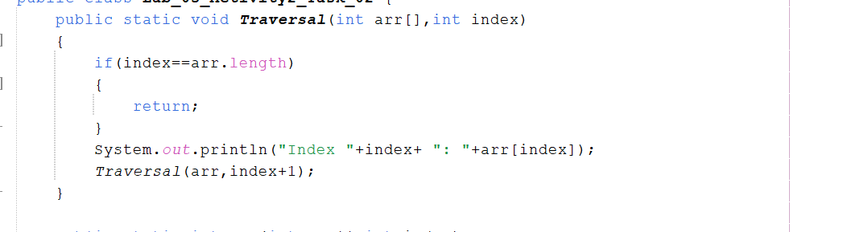
Recursive Statistics:

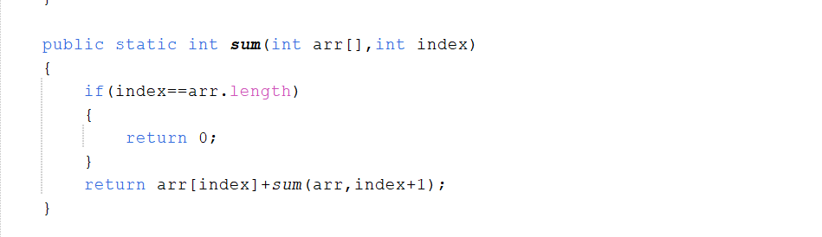
Recursive Search:
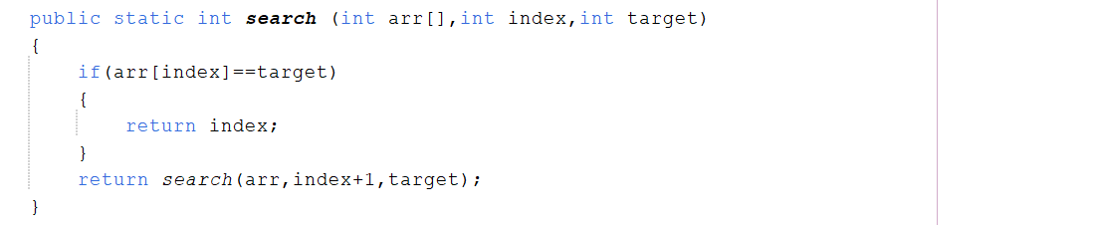
Complete Code:
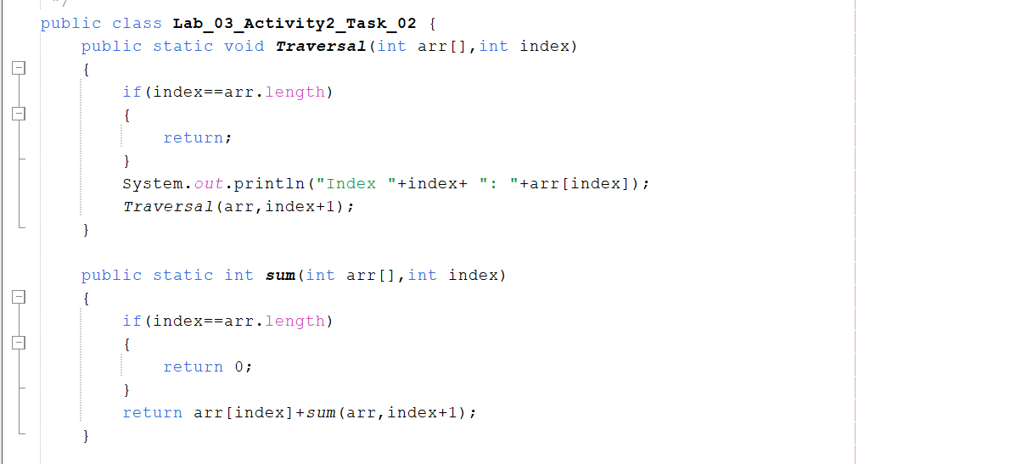
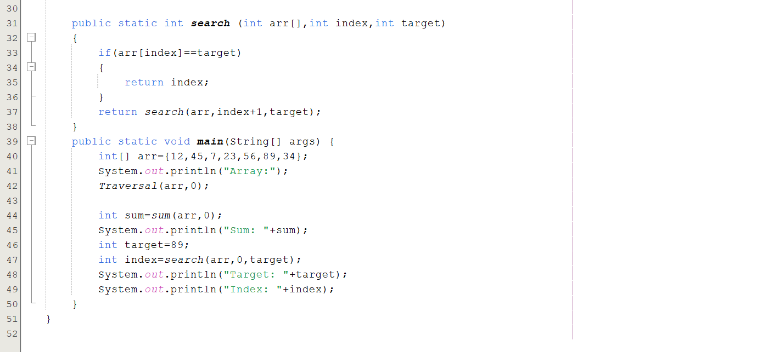
Output:
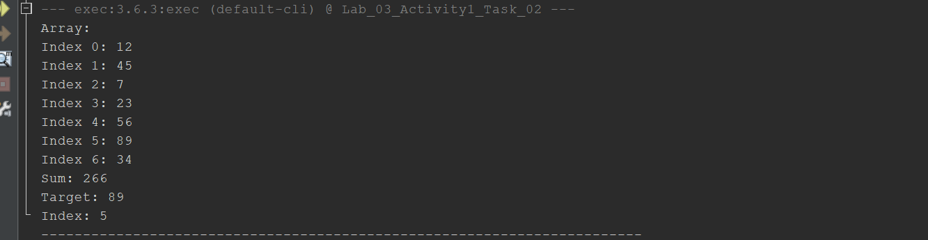
Lab Activity 2:
Task_01:
Activity 2 — Merge Sort & Quick Sort Implementation
Task Description:
Write a single, ready-to-run Java program that implements both the Merge Sort and Quick Sort algorithms using distinct recursive methods. Your main method must initialize an unsorted test array, showcase the sorting process for each algorithm, and print the state of the array before and after execution.
Review the implementation trace output below. Analyze how the elements shift in memory, perform a manual dry run on paper, and prepare to justify your algorithmic understanding. There will be an individual viva examination at the conclusion of this lab session. If you encounter any structural anomalies or logical confusion during your dry run, proactively raise your hand to ask your lab instructor for clarification.
java
public class SortingLabWithTraces {

public static void main(String[] args) {
// Initializing distinct test arrays to benchmark both algorithms
int[] arrayForMerge = {64, 25, 12, 22, 11, 90, 34};
int[] arrayForQuick = {64, 25, 12, 22, 11, 90, 34};

System.out.println("=================================================");
System.out.println("RUNNING MERGE SORT DEMO");
System.out.println("=================================================");
System.out.print("Initial State: ");
printFullArray(arrayForMerge);
System.out.println("\n");

mergeSort(arrayForMerge, 0, arrayForMerge.length - 1);

System.out.print("\nFinal Sorted Array (Merge Sort): ");
printFullArray(arrayForMerge);
System.out.println();

System.out.println("\n=================================================");
System.out.println("RUNNING QUICK SORT DEMO");
System.out.println("=================================================");
System.out.print("Initial State: ");
printFullArray(arrayForQuick);
System.out.println("\n");

quickSort(arrayForQuick, 0, arrayForQuick.length - 1);

System.out.print("\nFinal Sorted Array (Quick Sort): ");
printFullArray(arrayForQuick);
System.out.println();
}

// ==================== MERGE SORT IMPLEMENTATION ====================
public static void mergeSort(int[] arr, int left, int right) {
if (left < right) {
int mid = left + (right - left) / 2;

// Tracking the structural split boundaries
System.out.print("Splitting subarray: ");
printSubarray(arr, left, right);
System.out.println();

mergeSort(arr, left, mid); // Recursive call for left half
mergeSort(arr, mid + 1, right); // Recursive call for right half

merge(arr, left, mid, right); // Merge both halves back together
}
}

private static void merge(int[] arr, int left, int mid, int right) {
int n1 = mid - left + 1;
int n2 = right - mid;

int[] L = new int[n1];
int[] R = new int[n2];

// Manual copy instead of System.arraycopy to avoid built-in shortcuts
for (int i = 0; i < n1; i++) {
L[i] = arr[left + i];
}
for (int j = 0; j < n2; j++) {
R[j] = arr[mid + 1 + j];
}

System.out.print(" Merging parts -> Left: ");
printFullArray(L);
System.out.print(" and Right: ");
printFullArray(R);
System.out.println();

int i = 0, j = 0, k = left;
while (i < n1 && j < n2) {
if (L[i] <= R[j]) {
arr[k] = L[i];
i++;
} else {
arr[k] = R[j];
j++;
}
k++;
}

while (i < n1) {
arr[k] = L[i];
i++; k++;
}
while (j < n2) {
arr[k] = R[j];
j++; k++;
}

System.out.print(" Result after merge phase: ");
printSubarray(arr, left, right);
System.out.println();
}

// ==================== QUICK SORT IMPLEMENTATION ====================
public static void quickSort(int[] arr, int low, int high) {
if (low < high) {
System.out.print("Processing index range: ");
printSubarray(arr, low, high);
System.out.println();

int pi = partition(arr, low, high); // Find partition index location

quickSort(arr, low, pi - 1); // Recursive call for left partition
quickSort(arr, pi + 1, high); // Recursive call for right partition
}
}

private static int partition(int[] arr, int low, int high) {
int pivot = arr[high]; // Lomuto pivot selection strategy (last element)
System.out.println(" Selected Pivot Value: [" + pivot + "]");
int i = (low - 1);

for (int j = low; j < high; j++) {
if (arr[j] <= pivot) {
i++;
// Manual Swap mechanics
int temp = arr[i];
arr[i] = arr[j];
arr[j] = temp;
}
}

// Swap the pivot element with the element at index i + 1
int temp = arr[i + 1];
arr[i + 1] = arr[high];
arr[high] = temp;

System.out.print(" Current Array State after Partition: ");
printFullArray(arr);
System.out.println();
System.out.println(" Pivot element locked at index location: " + (i + 1));

return i + 1;
}

// ==================== MANUAL FOR-EACH DISPLAY UTILITY ====================

// Prints an entire passed array using a simple for-each loop structure
private static void printArray(int[] arr) {
for (int val : arr) {
System.out.print(val + " ");
}
System.out.println();
}

Solution:
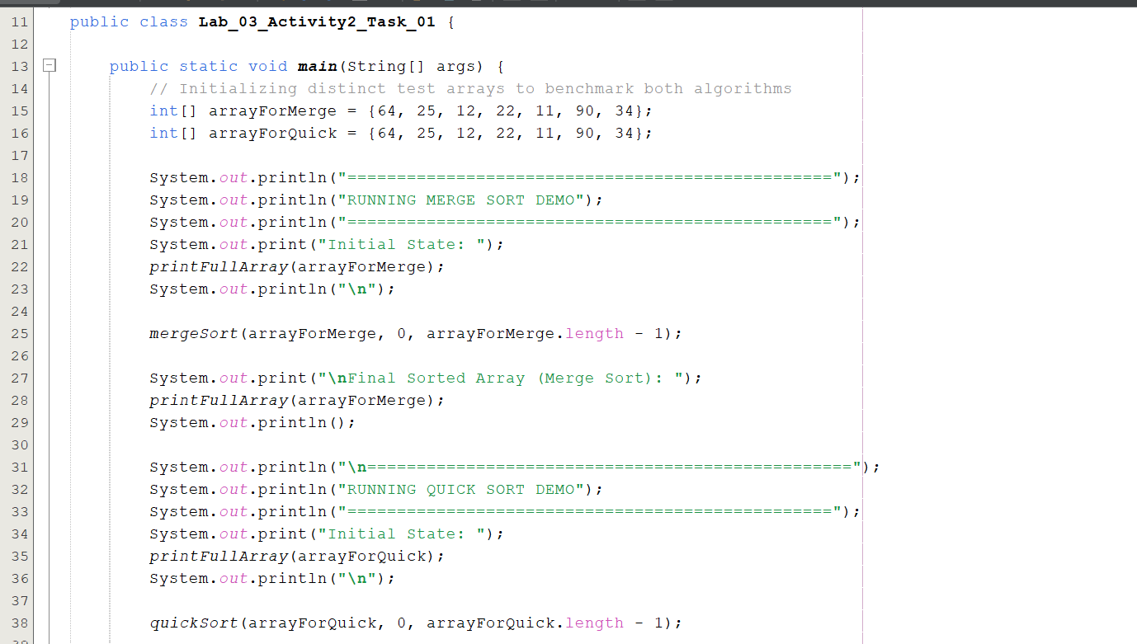
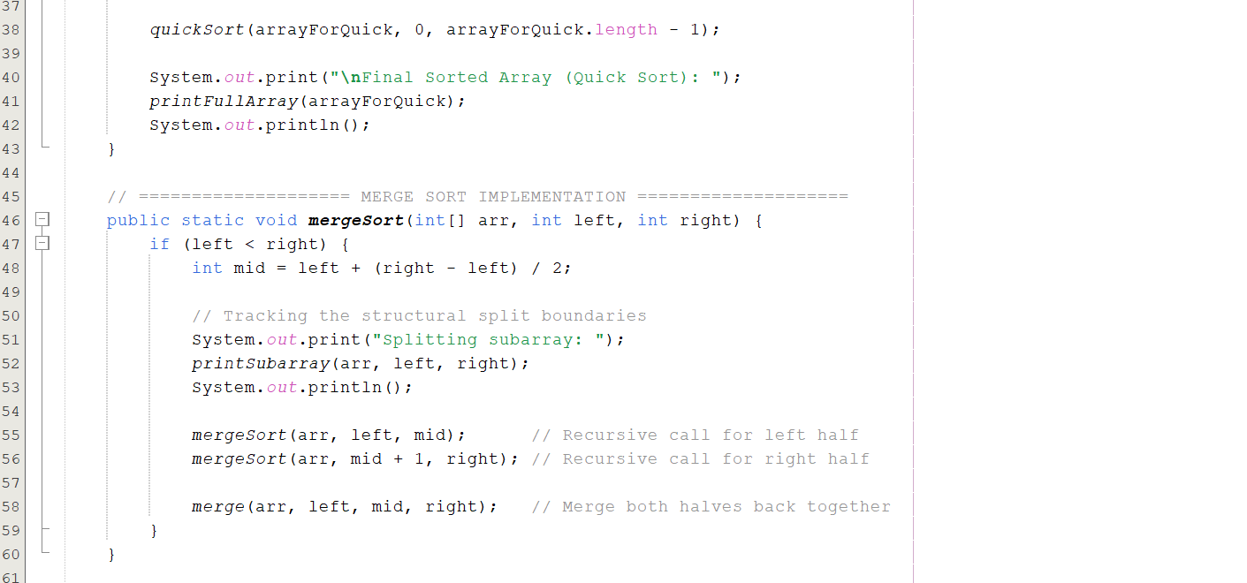
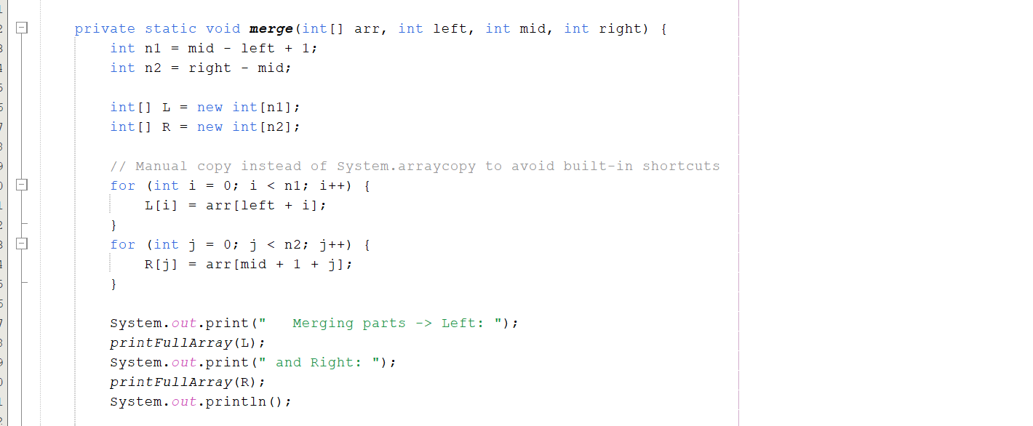
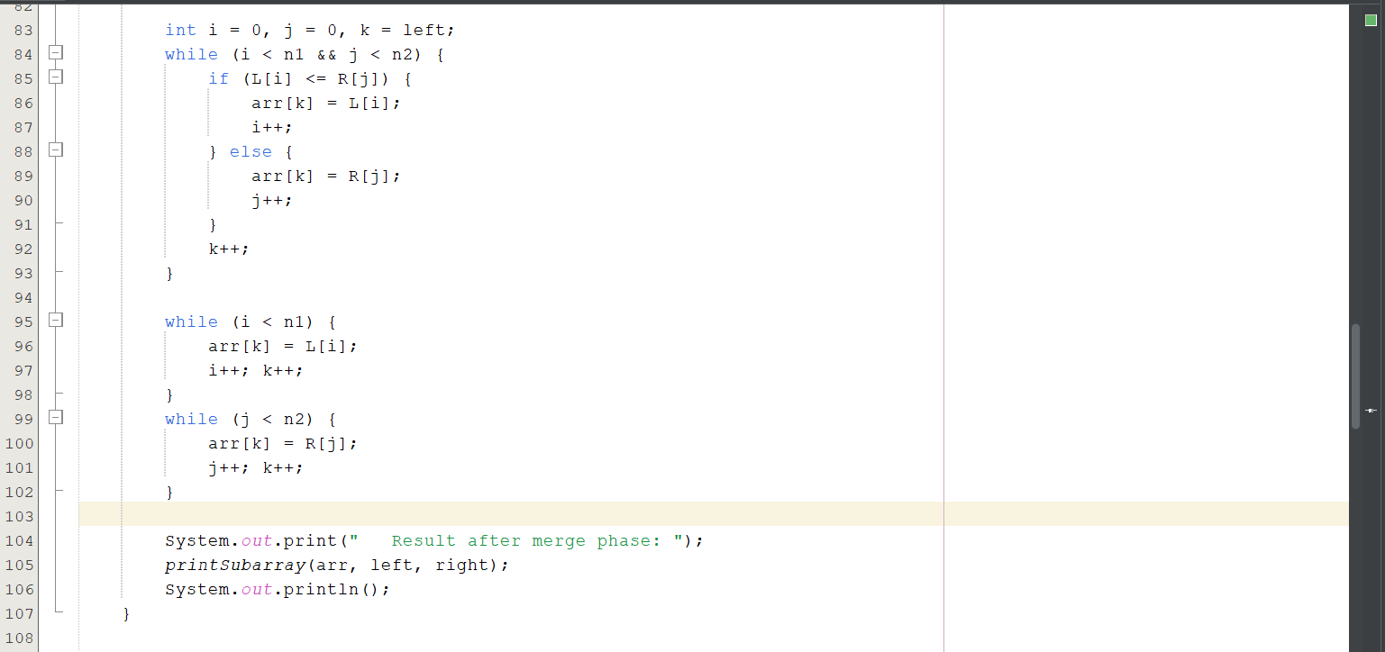
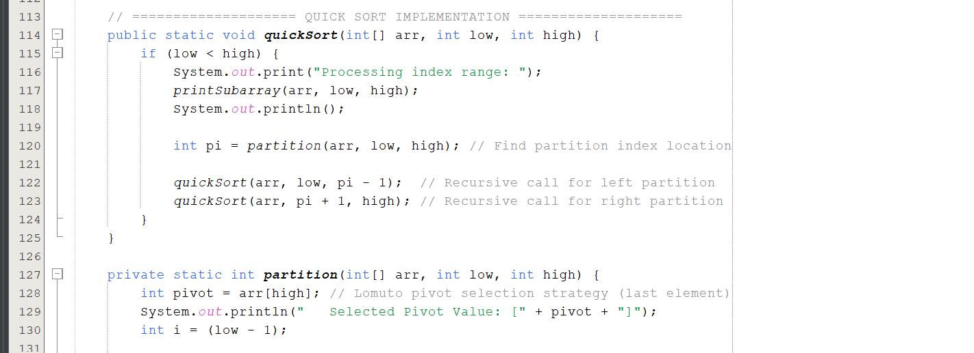
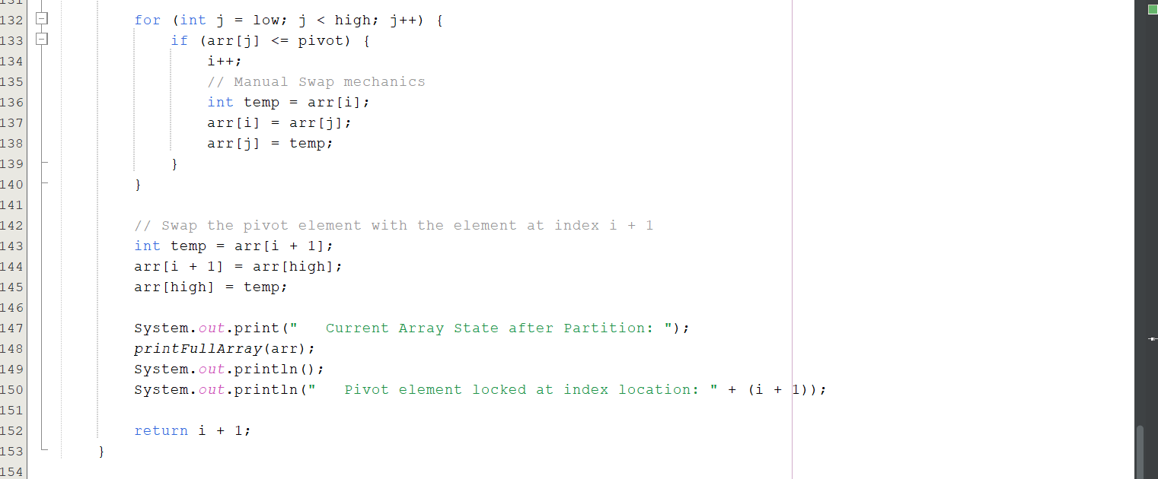
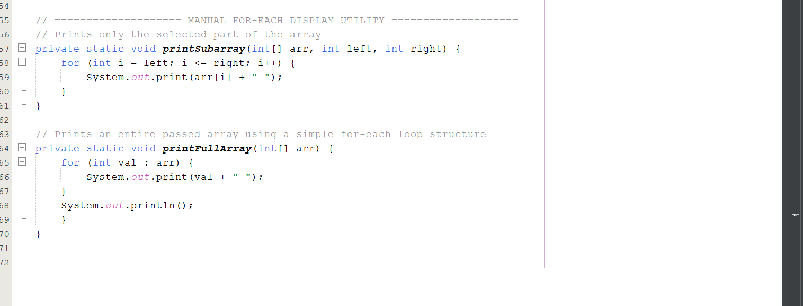

Output:
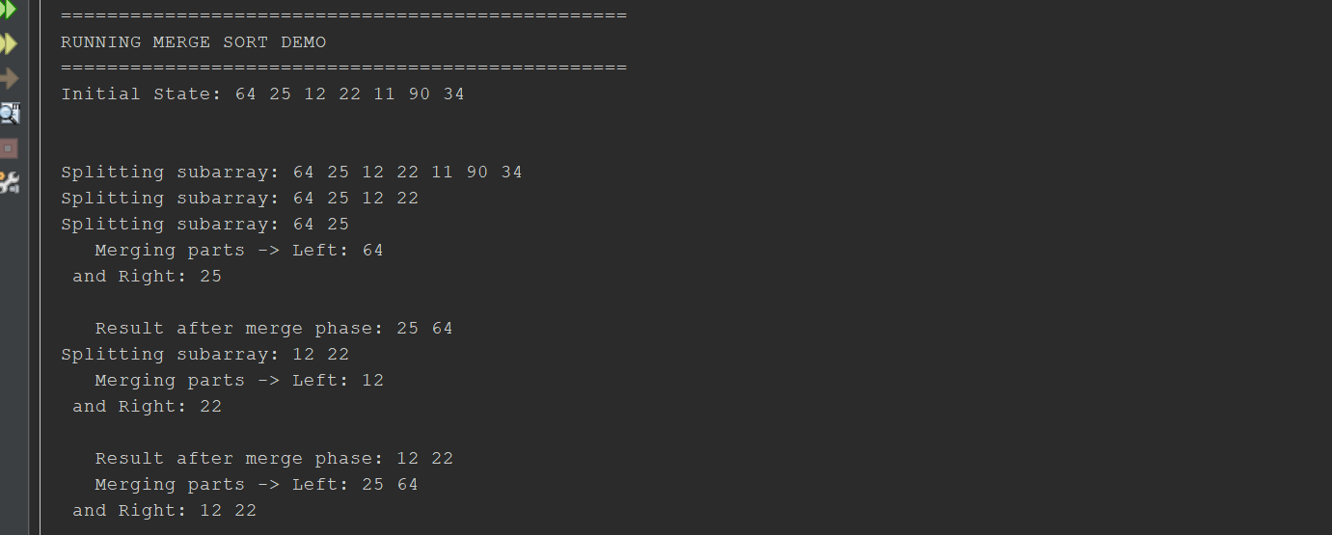
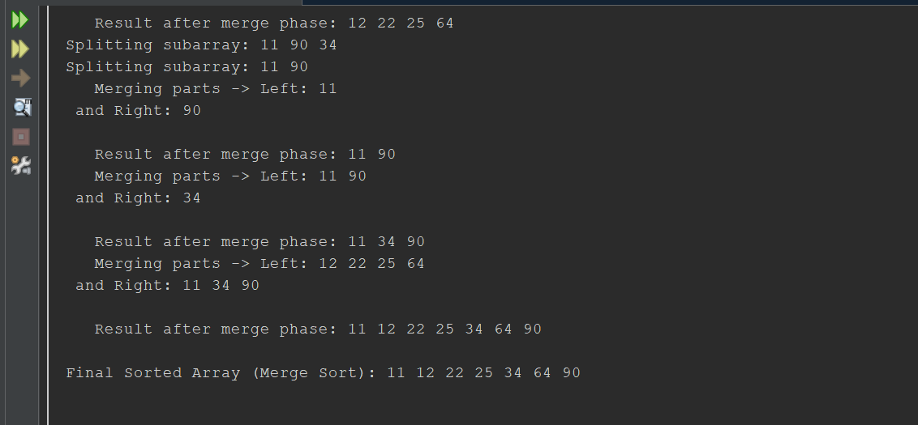
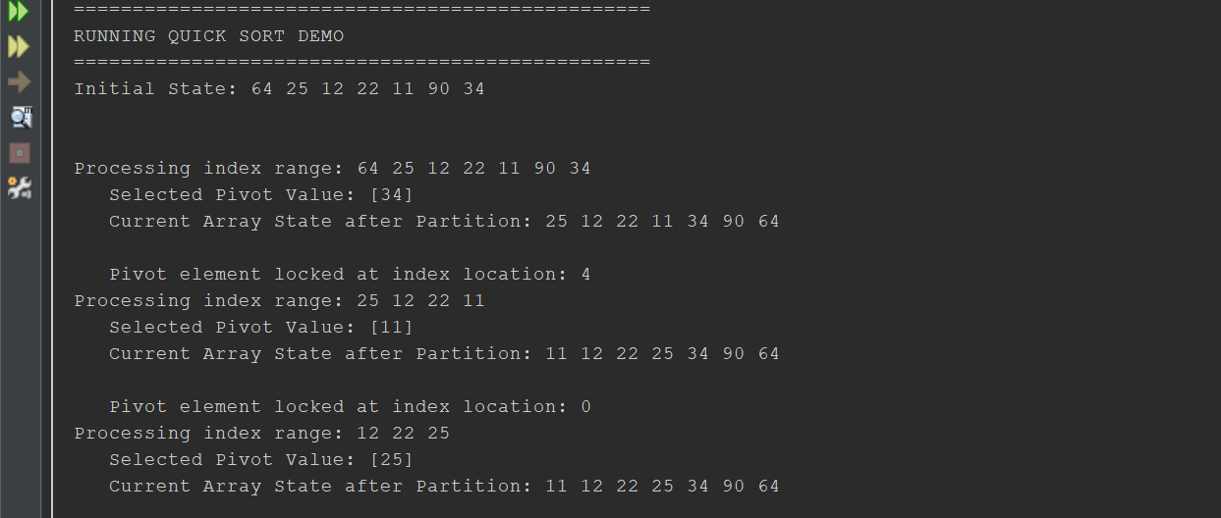
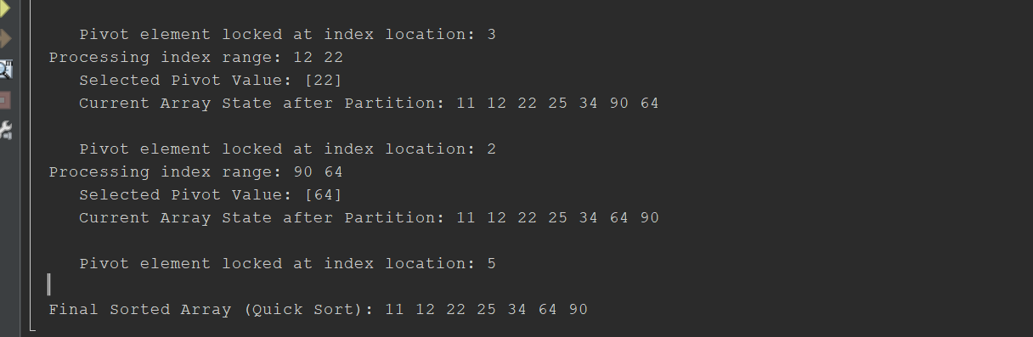

END

